Question 1: What happen is we are modifying a file, and middle of that we lost connection.

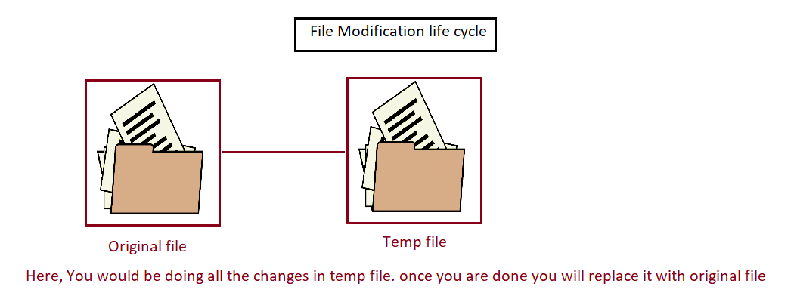

Question 2: Why sudo apt-get update is working whereas sudo cd is not working.

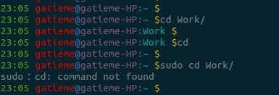

cd is a shell builtin. sudo only works with executables. You could do sudo sh -c 'cd dirname'